Chapter 18, Solution 34.

First, we find G(ω) for g(t) shown below.

The Fourier transform of each term gives

0
10
g(t)
t
2
1
–2
–1
20

0
g ‘(t)
t
2
1
–2
–1
–10δ(t-2)
–10δ(t-1)
10δ(t+2)
10δ(t+1)

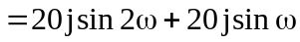
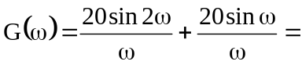40 sinc(2ω) + 20 sinc(ω)
Note that G(ω) = G(-ω).
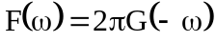
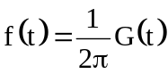
= (20/π)sinc(2t) + (10/π)sinc(t)

